**ASSIGNMENT-1 Data Types**

**Please implement by using Python.**

1. Construct 2 lists containing all the available data types (integer, float, string, complex and Boolean) and do the following..
   1. Create another list by concatenating above 2 lists
   2. Find the frequency of each element in the concatenated list.
   3. Print the list in reverse order.

**Answer: a)**

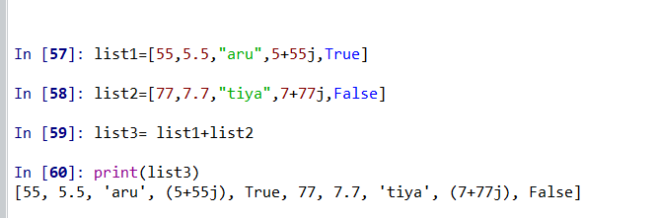

**b)** 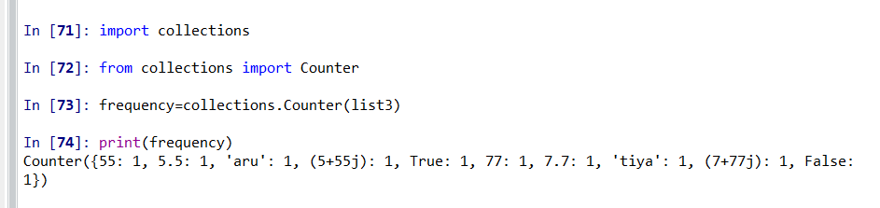

**c)**

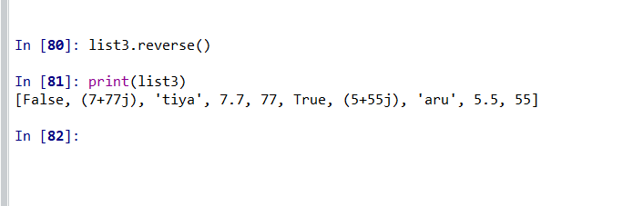

1. Create 2 Sets containing integers (numbers from 1 to 10 in one set and 5 to 15 in other set)
   1. Find the common elements in above 2 Sets.
   2. Find the elements that are not common.
   3. Remove element 7 from both the Sets.

**Answers: a)**

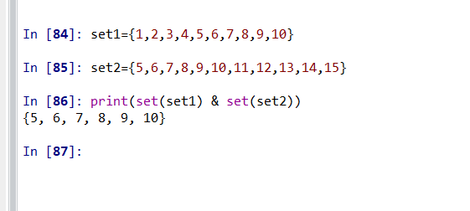

**b)**

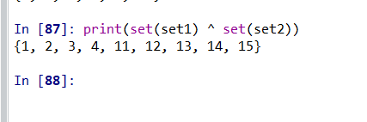

**C)**

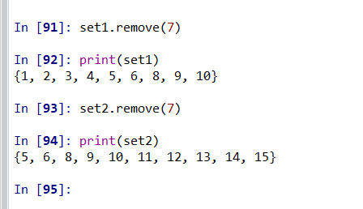

1. Create a data dictionary of 5 states having state name as key and number of covid-19 cases as values.
   1. Print only state names from the dictionary.
   2. Update another country and it’s covid-19 cases in the dictionary.

**Answer:**

**a)**

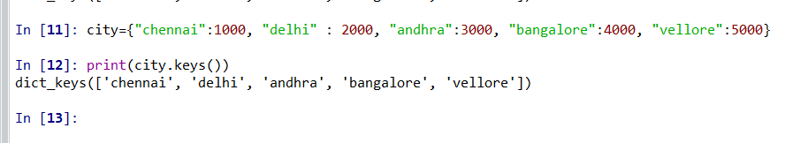

**b)**

